1,a

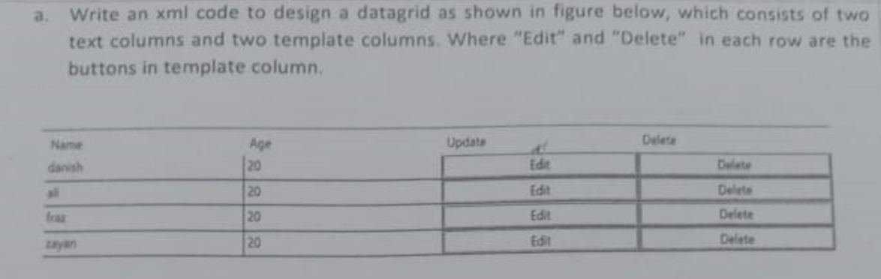

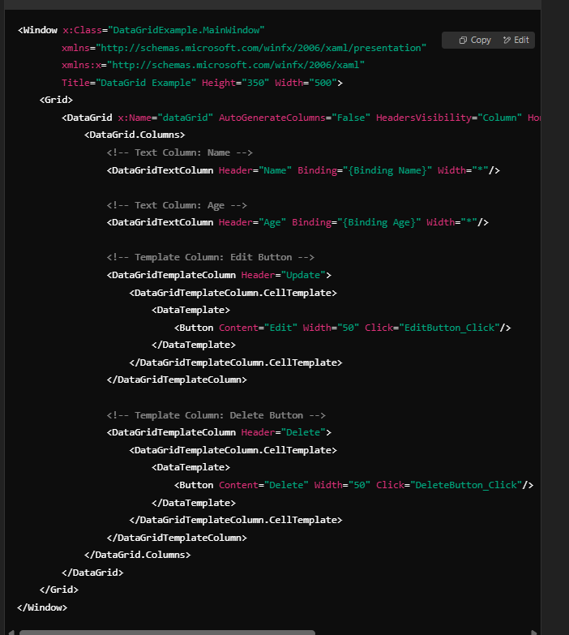

<Window x:Class="DataGridExample.MainWindow"

xmlns="http://schemas.microsoft.com/winfx/2006/xaml/presentation"

xmlns:x="http://schemas.microsoft.com/winfx/2006/xaml"

Title="DataGrid Example" Height="350" Width="500">

<Grid>

<DataGrid x:Name="dataGrid" AutoGenerateColumns="False" HeadersVisibility="Column" HorizontalAlignment="Center" VerticalAlignment="Center" Width="450">

<DataGrid.Columns>

<!-- Text Column: Name -->

<DataGridTextColumn Header="Name" Binding="{Binding Name}" Width="*"/>

<!-- Text Column: Age -->

<DataGridTextColumn Header="Age" Binding="{Binding Age}" Width="*"/>

<!-- Template Column: Edit Button -->

<DataGridTemplateColumn Header="Update">

<DataGridTemplateColumn.CellTemplate>

<DataTemplate>

<Button Content="Edit" Width="50" Click="EditButton_Click"/>

</DataTemplate>

</DataGridTemplateColumn.CellTemplate>

</DataGridTemplateColumn>

<!-- Template Column: Delete Button -->

<DataGridTemplateColumn Header="Delete">

<DataGridTemplateColumn.CellTemplate>

<DataTemplate>

<Button Content="Delete" Width="50" Click="DeleteButton_Click"/>

</DataTemplate>

</DataGridTemplateColumn.CellTemplate>

</DataGridTemplateColumn>

</DataGrid.Columns>

</DataGrid>

</Grid>

</Window>

Optional(1a)  
using System.Collections.Generic;

using System.Windows;

using System.Windows.Controls;

namespace DataGridExample

{

public partial class MainWindow : Window

{

public class Person

{

public string Name { get; set; }

public int Age { get; set; }

}

public MainWindow()

{

InitializeComponent();

LoadData();

}

private void LoadData()

{

List<Person> people = new List<Person>

{

new Person { Name = "danish", Age = 20 },

new Person { Name = "ali", Age = 20 },

new Person { Name = "fraz", Age = 20 },

new Person { Name = "zayan", Age = 20 }

};

dataGrid.ItemsSource = people;

}

private void EditButton_Click(object sender, RoutedEventArgs e)

{

MessageBox.Show("Edit button clicked!");

}

private void DeleteButton_Click(object sender, RoutedEventArgs e)

{

MessageBox.Show("Delete button clicked!");

}

}

}

# 1,b

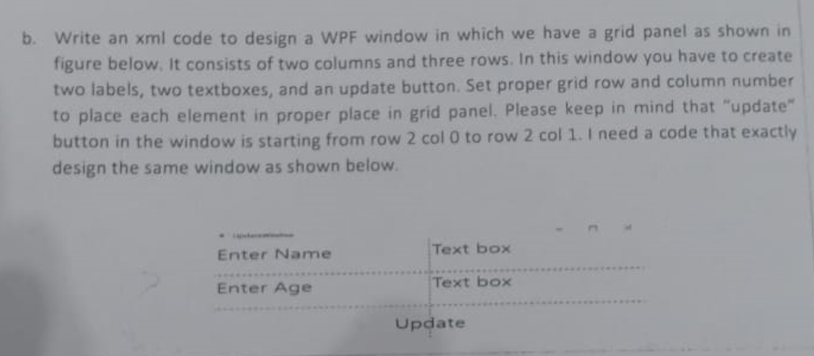

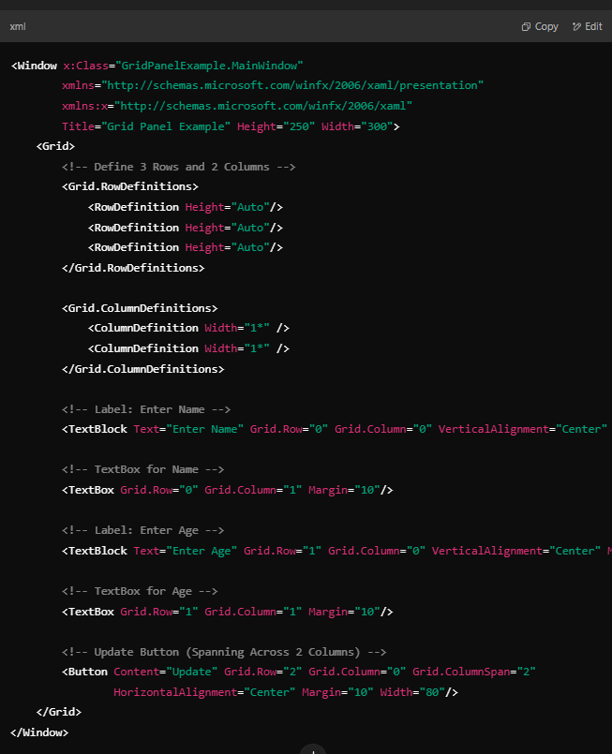

# 2

